The purpose of this review is to get you familiar with the out-of-the-box Sage CRM main search screens and summary tabs. During your live business modeling session with a consultant you will indicate the changes that you would like to make to the existing CRM screens.
Reviewing and populating this document gives you the opportunity to review and discuss needed fields and changes with your team prior to your session. If you have any questions regarding the document or the fields, please contact your designated consultant.
Review each section of the Business Modeling guide and images.
Each page has corresponding sections for you to designate any fields that need to be removed or added. Fields may be re-positioned. You may decide to indicate this visually - by drawing on the image and scanning the document for submission to your consultant prior to the session or simply making a note on the last page of this document.
Document as much as possible prior to your live Business Modeling session with an OnTrack Consultant to make the most of your time together. Also, take the opportunity to fill in the Notes portion of each section to indicate thoughts, remarks, needs and questions that you have associated with the particular screen.
Summary tabs in CRM are used to present a high-level view of the entity in focus. In the case of Companies and People, the address displayed on the summary page is the default address. The person listed on the Company Summary tab is the default contact. Additional addresses can be found on the Address tabs under an individual Company and Person. Additional contacts can be found on the People tab under an individual Company.
Opportunities in CRM are used to track the sales process. Any information that is pertinent to a potential sale should be gathered in this portion of the system.

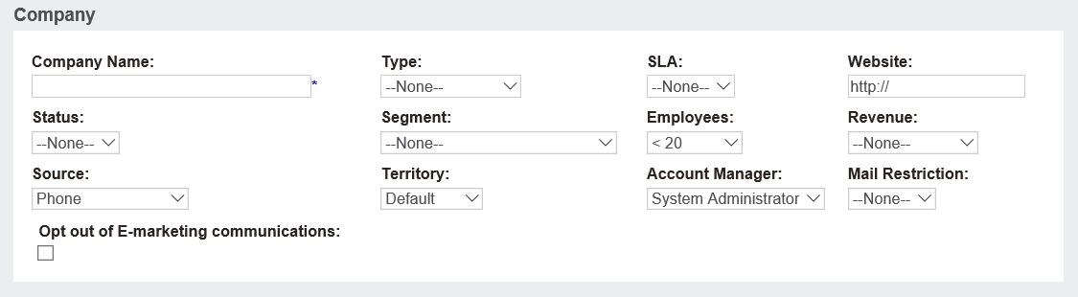

Type -- This list must include Customer. It can also include: Prospect, Vendor, Competitor, Supplier, etc. It's a way to indicate which type of Company the record contains.

SLA -- Stands for Service Level Agreement. If you have contracts of different levels for which your customers sign up, then you probably use SLA's. For example your customers may be Gold, Silver, or Bronze. For Gold customers you respond to issues within 4 hours. **This is a commonly omitted field from CRM. 95% of organizations using Sage CRM do not use this field.

Status -- Common status options are Active or Inactive. Since we don't recommend deleting records from CRM, you can always mark a record as Inactive and then leave those out of searches or reports when necessary.

Segment -- This is the market segment of the company. For example this list can include: Government, Hospital, Engineering, Retail, etc. The field can be used for slicing/dicing and reporting on data later. This field should be used as an identifier.

Employees -- The number of employees at the company. This is currently a range field.

Revenue -- The revenue of a company (not your revenue from that company). If you have this data and it's important to you, you can use ranges to identify how big a customer or prospect is.

Source -- How did you obtain this Prospect/Customer? Was it by Phone, Marketing, Email, Web Form, etc.

Territory -- Segmentations of your business generally by region. For example you may have US and UK territories, but then under US have an East, West, and Central territory. Territories are tree type structures and should not be changed frequently. Do not use Salesperson names to designate territories -- as salespeople change.

Omit the following fields from the tab:

Questions about fields on the tab:

Add the following fields to the tab:

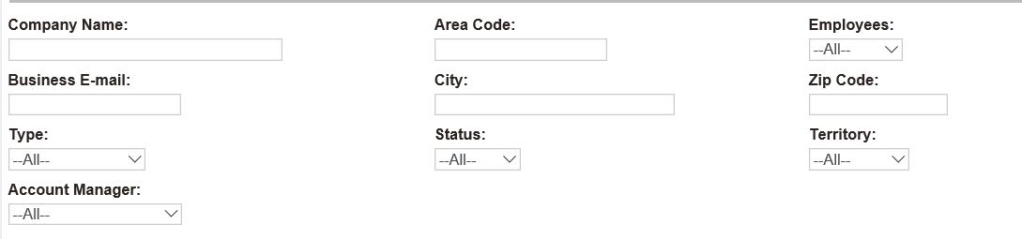

Omit the following fields from the screen:

Add the following fields from the tab (either new from the previous page or existing fields from the Company Summary):

Questions about fields on the screen or search screen capabilities/functionality:

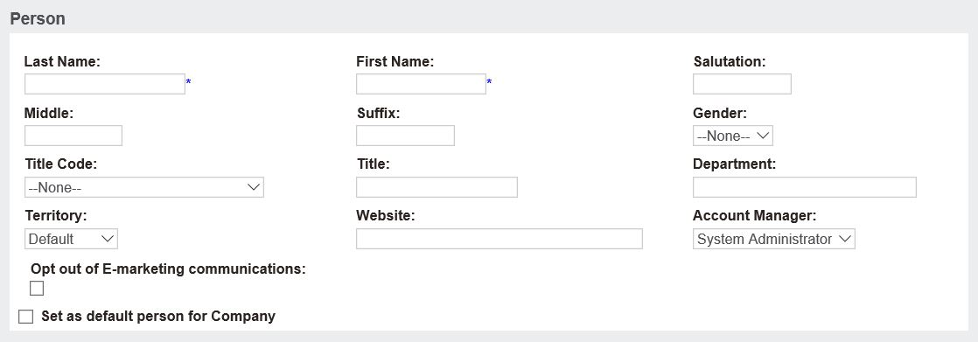

Title Code -- This is a general title for the individual. You want to make this list a little more generic than general titles go. For example your list may include: Purchaser, Salesperson, Vice President, President, Owner, Payables, Engineer, Physician, etc.

Title -- Is a free text field that allows uers to key in an exact title. So, the Title Code may be set to Vice President, but the Title field can say VP of Sales for East Coast.

Website -- This is the individual's website, not the company for which they work. So, it can be used for a LinkedIn page, Facebook, or other personal webpage. This is a commonly omitted field.

Omit the following fields from the tab:

Questions about fields on the tab:

Add the following fields to the tab:

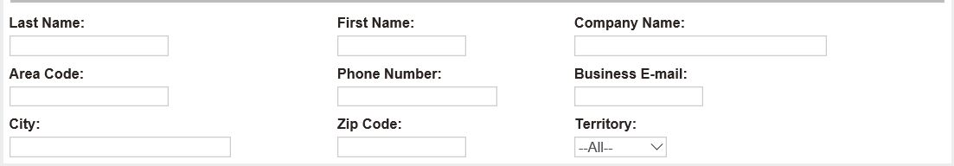

Omit the following fields from the screen:

Add the following fields from the tab (either new from the previous page or existing fields from the Person Summary):

Questions about fields on the screen or search screen capabilities/functionality:

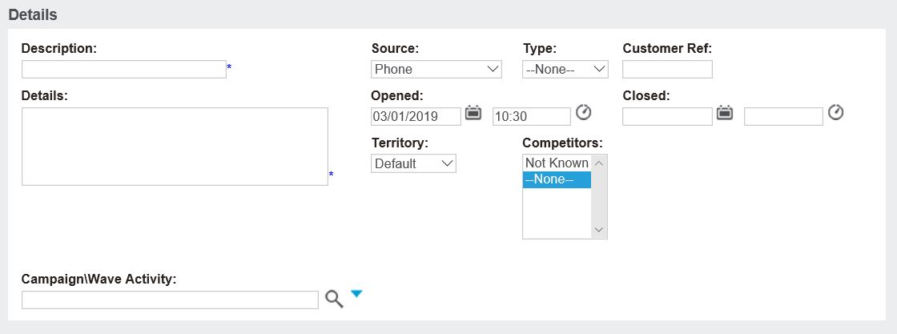

Desicription -- A description of the opportunity (potential sale).

Customer Ref -- Used to capture a PO# or other customer provided value tied to the sale.

Omit the following fields from the tab:

Questions about fields on the tab:

Add the following fields to the tab:

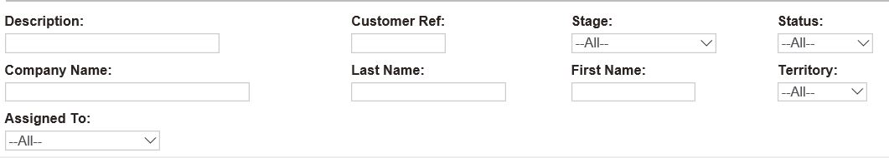

Omit the following fields from the screen:

Add the following fields from the tab (either new from the previous page or existing fields from the Opportunity Summary):

Questions about fields on the screen or search screen capabilities/functionality:

